**LIBRARY MANAGEMENT SYSTEM**

**Date :**

**Ex No :**

**AIM:**

To Design ,Implement and Test the LIBRARY MANAGEMENT SYSTEM described in the given problem statement .

**PROBLEM STATEMENT:**

The library management system is a software system that issues books and magazines to registered students only. The student has to login after getting registered to the system. The borrower of the book can perform various functions such as searching for desired book, get the issued book and return the book..

**USECASE DIAGRAM:**

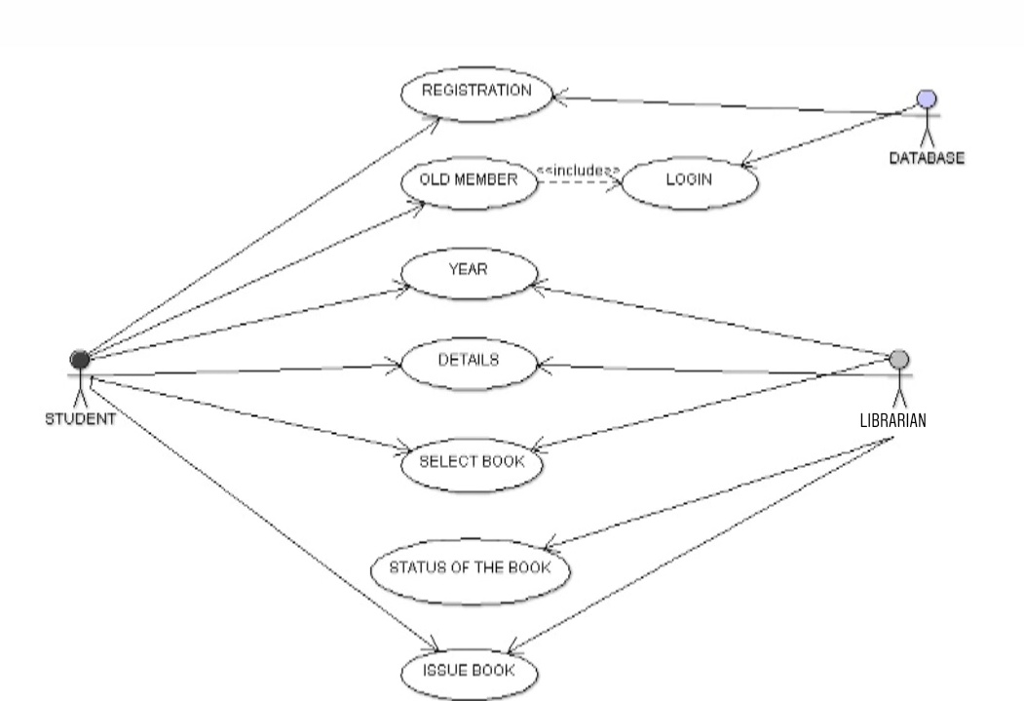

**CLASS DIAGRAM:**

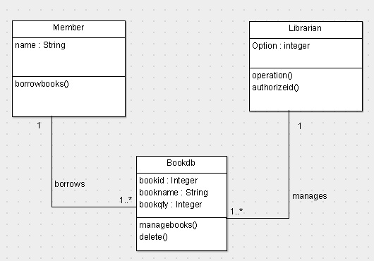

**SEQUENCE DIAGRAM:**

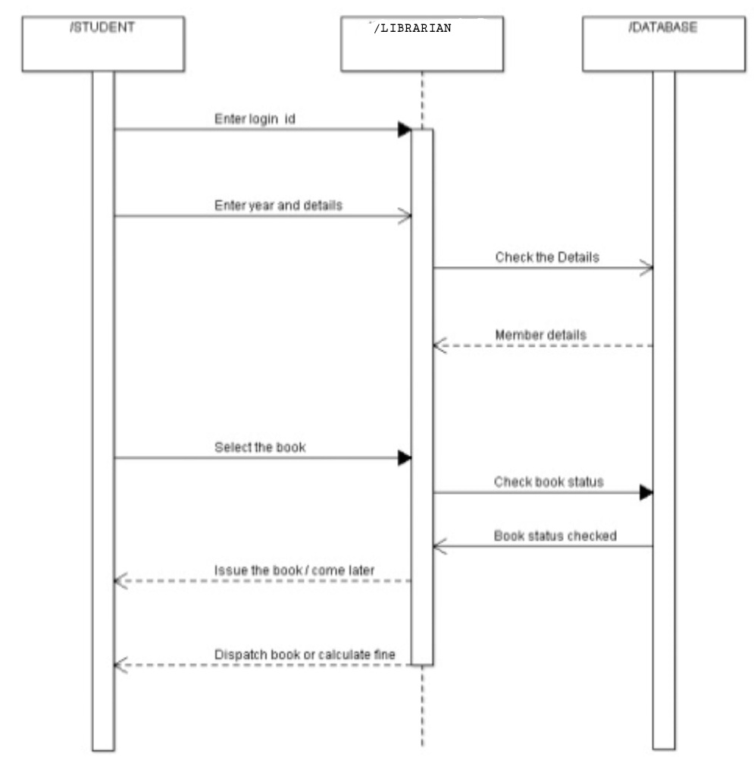

**COLLABORATION DIAGRAM:**

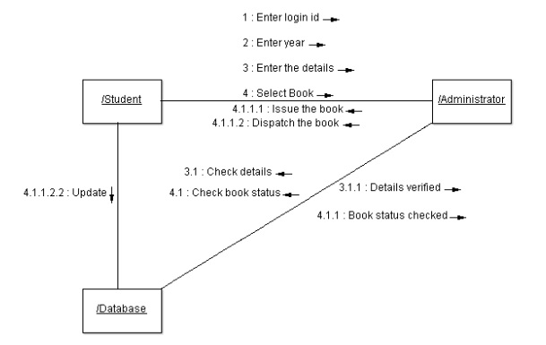

**ACTIVITY DIAGRAM:**

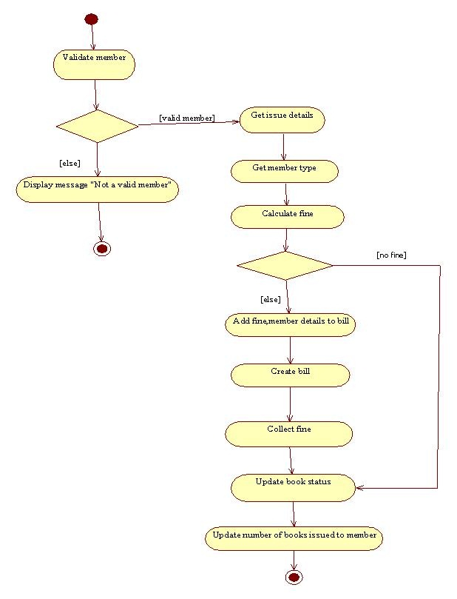

**STATE CHART DIAGRAM:**



**COMPONENT DIAGRAM:**



**DEPLOYMENT DIAGRAM:**



**IMPLEMENTATION & TESTING**

**Librarian.java**

package Library;

import java.util.Scanner;

import java.io.*;

class Librarian extends Book

{

public void operation()

{

int a;

do

{

System.out.println("select an option");

System.out.println("1.Admin login\t2.Member login\t3.exit");

Scanner s=new Scanner(System.in);

int m=s.nextInt();

switch(m)

{

case 1:

{

BookDb p=new BookDb();

p.managebook();

break;

}

case 2:

{

Member c=new Member();

c.order();

break;

}

case 3:

System.exit(0);

}

System.out.println("enter 1 to continue to select login");

a=s.nextInt();

}while(a==1);

}

**BookDb.java**

package Library;

import java.util.*;

import java.io.*;

class BookDb extends Member

{

int t;int f;int i=0;int count=0,count1=0;

public static int[] bid=new int[100];

public static String[] bname=new String[100];

public static int[] qty=new int[100];

public static int[] ord=new int[100];

public void managebook()

{

Scanner s=new Scanner(System.in);

do

{

System.out.println("1.Add\n 2.display\n 3.delete\n 4.update\n");

System.out.println("enter the option");

int n=s.nextInt();

switch(n)

{

case 1:

System.out.println("enter the number of Books to be added");

int no=s.nextInt();

System.out.println("enter the id,name,qty of the Book");

no=no-1;

int f=i+no;

for(;i<=f;i++)

{

bid[i]=s.nextInt();

bname[i]=s.next();

qty[i]=s.nextInt();

}

i=i;

System.out.println("Books added successfully");

break;

case 2:

System.out.println("enter the number of Books to be printed");

int scan=s.nextInt();

for(int i=0;i<scan;i++)

{

System.out.println("Bookid Bookname qty ");

System.out.println(bid[i]+"\t"+bname[i]+"\t"+qty[i]);

}

System.out.println("The Books informations are displayed");

break;

case 3:

System.out.println("enter the id of the Book to be deleted");

int did=s.nextInt();

for(int i=0;i<=bid.length-1;i++)

{

if(bid[i]!=0)

{

count++;

}

}

for(i=0;i<=count+1;i++)

{

if(bid[i]==did)

{

bid[i]=bid[count-1];

bname[i]=bname[count-1];

qty[i]=qty[count-1];

bid[count-1]=bid[bid.length-1];

bname[count-1]=bname[bname.length-1];

qty[count-1]=qty[qty.length-1];

break;

}

}

System.out.println("Boook is successfully deleted");

break;

case 4:

System.out.println("enter the id,name,qty of the Book to be added");

int nid=s.nextInt();

String nname=s.next();

int nqty=s.nextInt();

for(int i=0;i<=bid.length;i++)

{

if(bid[i]==nid)

{

bid[i]=nid;

bname[i]=nname;

qty[i]=nqty;

break;

}

}

System.out.println("Book is updated successfully");

break;

case 5:

System.exit(0);

}

System.out.println("enter 1 to continue to manage Books");

t=s.nextInt();

}while(t==1);

}

public static void main(String args[])

{

Admin sp=new Admin();

sp.operation();

}

public void delete(int n)

{

int did=n;

for(int i=0;i<=bid.length-1;i++)

{

if(i!=0)

{

count1++;

}

}

for(int i=0;i<=count1;i++)

{

if(bid[i]==did)

{

qty[i]=qty[count1];

break;

}

}

}

}

**Member.java**

package Library;

import java.util.*;

import java.io.*;

class Member

{

public void borrow()

{

Scanner s=new Scanner(System.in);

Book p=new Book();

System.out.println("enter the Book id to be ordered");

int search=s.nextInt();

p.delete(search);

System.out.println("Enter your library card id:");

int b=s.nextInt();

if(b==123)

{

Member c=new Member();

c.authorizeid();

}

}

public void authorizeid()

{

System.out.println("borrow successfull");

}

}

**OUTPUT:**

Select an option

1 .Librarian login

2. Member login

3. exit

Your option: 1

1.Add

2.display

3.delete

4.update

enter the option

1

enter the number of items to be added

2

enter the id, name, qty of the product to be added

7890

A monster calls

3

9011

Refugee boy

1

Items added successfully

enter 1 to continue to manage product

2

enter 1 to continue to select login

1

select an option

1.Librarian login

2.Member login

3.exit

Your option:1

1.Add

2.display

3.delete

4.update

enter the option

2

enter the number of items to be printed

2

Bookid Book name qty

7890 A monster calls 3

9011 Refugee boy 1

the product information is displayed

enter 1 to continue to manage product

1

1.Add

2.display

3.delete

4.update

enter the option

3

enter the id of the product to be deleted

9011

product is successfully deleted

enter 1 to continue to manage product

1

1.Add

2.display

3.delete

4.update

enter the option

4

enter the id , name , qty of the product to be added

2312

Skullduggery

3

product is updated successfully

enter 1 to continue to manage product

1

1.Add

2.display

3.delete

4.update

enter the option

2

enter the number of items to be printed

2

Bookid Book name qty

2312 Skullduggery 3

9011 Refugee boy 1

the product information is displayed

enter 1 to continue to manage product

0

enter 1 to continue to select login

1

select an option

1.Librarian login

2.Member login

3.exit

Your option:2

enter the product id to be borrowed

2312

Enter your library card id:123

item borrowed successfully

enter 1 to continue to select login

1

select an option

1.Admin login

2.Member login

3.exit

1

1.Add

2.display

3.delete

4.update

enter the option

2

enter the number of items to be printed

2

Bookid Book name qty

9011 Refugee boy 1

the product information is displayed

enter 1 to continue to manage product

1

enter 1 to select login

select an option

1.Admin login

2.Member login

3.exit

Your option:3

**TEST REPORT 1**

**Product : Library Management System**

**Use Case :** Login Check

|  |  |  |  |  |
| --- | --- | --- | --- | --- |
| **Test Case ID** | **Test Case / Action To Perform** | **Expected Result** | **Actual Result** | **Pass/Fail** |
| 1. 1 | Enter option 1 to login as Librarian | Librarian Access | Library Access verified | Pass |
|  | Enter option 2 to login as  Member | Member Access | Member Access verified | Pass |
|  | Enter option 3 to exit | Exit | Exit | Pass |

**TEST REPORT 2**

**Product :** **Library Management System**

**Use Case :** Adding and Displaying Books

|  |  |  |  |  |
| --- | --- | --- | --- | --- |
| **Test Case ID** | **Test Case / Action To Perform** | **Expected Result** | **Actual Result** | **Pass/Fail** |
|  | Enter 1 to add new books | Enter book id,name,quantity  To add books | Books added | Pass |
|  | Enter 2 to display books | Print books in order | Books  displayed | Pass |

**TEST REPORT 3**

**Product :** **Library Management System**

**Use Case :** Borrow books

|  |  |  |  |  |
| --- | --- | --- | --- | --- |
| **Test Case ID** | **Test Case / Action To Perform** | **Expected Result** | **Actual Result** | **Pass/Fail** |
| 1 | Enter Registered id and book id to borrow books | Borrowed if registered | Books Borrowed | Pass |